| Please choose a lesson, or type 0 to return to course menu.

1: Principles of Analytic Graphs 2: Exploratory Graphs

3: Graphics Devices in R 4: Plotting Systems

5: Base Plotting System 6: Lattice Plotting System

7: Working with Colors 8: GGPlot2 Part1

9: GGPlot2 Part2 10: GGPlot2 Extras

11: Hierarchical Clustering 12: K Means Clustering

13: Dimension Reduction 14: Clustering Example

15: CaseStudy

Selection: 2

| | 0%

| Exploratory_Graphs. (Slides for this and other Data Science courses may be found at github

| https://github.com/DataScienceSpecialization/courses/. If you care to use them, they must be

| downloaded as a zip file and viewed locally. This lesson corresponds to

| 04_ExploratoryAnalysis/exploratoryGraphs.)

...

|= | 1%

| In this lesson, we'll discuss why graphics are an important tool for data scientists and the

| special role that exploratory graphs play in the field.

...

|== | 3%

| Which of the following would NOT be a good reason to use graphics in data science?

1: To suggest modeling strategies

2: To understand data properties

3: To find a color that best matches the shirt you're wearing

4: To find patterns in data

Selection: 3

| That's the answer I was looking for.

|==== | 4%

| So graphics give us some visual form of data, and since our brains are very good at seeing

| patterns, graphs give us a compact way to present data and find or display any pattern that may be

| present.

...

|===== | 5%

| Which of the following cliches captures the essence of graphics?

1: A picture is worth a 1000 words

2: The apple doesn't fall far from the tree

3: To err is human, to forgive divine

4: A rose by any other name smells as sweet

Selection: 1

| Perseverance, that's the answer.

|====== | 7%

| Exploratory graphs serve mostly the same functions as graphs. They help us find patterns in data

| and understand its properties. They suggest modeling strategies and help to debug analyses. We

| DON'T use exploratory graphs to communicate results.

...

|======= | 8%

| Instead, exploratory graphs are the initial step in an investigation, the "quick and dirty" tool

| used to point the data scientist in a fruitful direction. A scientist might need to make a lot of

| exploratory graphs in order to develop a personal understanding of the problem being studied. Plot

| details such as axes, legends, color and size are cleaned up later to convey more information in an

| aesthetically pleasing way.

...

|========= | 9%

| To demonstrate these ideas, we've copied some data for you from the U.S. Environmental Protection

| Agency (EPA) which sets national ambient air quality standards for outdoor air pollution. These

| Standards say that for fine particle pollution (PM2.5), the "annual mean, averaged over 3 years"

| cannot exceed 12 micro grams per cubic meter. We stored the data from the U.S. EPA web site in the

| data frame pollution. Use the R function head to see the first few entries of pollution.

> head(pollution)

pm25 fips region longitude latitude

1 9.771185 01003 east -87.74826 30.59278

2 9.993817 01027 east -85.84286 33.26581

3 10.688618 01033 east -87.72596 34.73148

4 11.337424 01049 east -85.79892 34.45913

5 12.119764 01055 east -86.03212 34.01860

6 10.827805 01069 east -85.35039 31.18973

| You're the best!

|========== | 11%

| We see right away that there's at least one county exceeding the EPA's standard of 12 micrograms

| per cubic meter. What else do we see?

...

|=========== | 12%

| We see 5 columns of data. The pollution count is in the first column labeled pm25. We'll work

| mostly with that. The other 4 columns are a fips code indicating the state (first 2 digits) and

| county (last 3 digits) with that count, the associated region (east or west), and the longitude and

| latitude of the area. Now run the R command dim with pollution as an argument to see how long the

| table is.

> dim(pollution)

[1] 576 5

| That's the answer I was looking for.

|============ | 13%

| So there are 576 entries in pollution. We'd like to investigate the question "Are there any

| counties in the U.S. that exceed that national standard (12 micro grams per cubic meter) for fine

| particle pollution?" We'll look at several one dimensional summaries of the data to investigate

| this question.

...

|============= | 15%

| The first technique uses the R command summary, a 5-number summary which returns 6 numbers. Run it

| now with the pm25 column of pollution as its argument. Recall that the construct for this is

| pollution$pm25.

> summary(pollution$pm25)

Min. 1st Qu. Median Mean 3rd Qu. Max.

3.383 8.549 10.050 9.836 11.360 18.440

| That's a job well done!

|=============== | 16%

| This shows us basic info about the pm25 data, namely its Minimum (0 percentile) and Maximum (100

| percentile) values, and three Quartiles of the data. These last indicate the pollution measures at

| which 25%, 50%, and 75% of the counties fall below. In addition to these 5 numbers we see the Mean

| or average measure of particulate pollution across the 576 counties.

...

|================ | 17%

| Half the measured counties have a pollution level less than or equal to what number of micrograms

| per cubic meter?

1: 9.836

2: 8.549

3: 10.050

4: 11.360

Selection: 3

| You got it!

|================= | 19%

| To save you a lot of typing we've saved off pollution$pm25 for you in the variable ppm. You can use

| ppm now in place of the longer expression. Try it now as the argument of the R command quantile.

| See how the results look a lot like the results of the output of the summary command.

> quantile(ppm)

0% 25% 50% 75% 100%

3.382626 8.548799 10.046697 11.356012 18.440731

| Excellent work!

|================== | 20%

| See how the results are similar to those returned by summary? Quantile gives the quartiles, right?

| What is the one value missing from this quantile output that summary gave you?

1: the minimum value

2: the median

3: the maximum value

4: the mean

Selection: 4

| That's the answer I was looking for.

|==================== | 21%

| Now we'll plot a picture, specifically a boxplot. Run the R command boxplot with ppm as an input.

| Also specify the color parameter col equal to "blue".

> boxplot(ppm, col = "blue")

| Excellent job!

|===================== | 23%

| The boxplot shows us the same quartile data that summary and quantile did. The lower and upper

| edges of the blue box respectively show the values of the 25% and 75% quantiles.

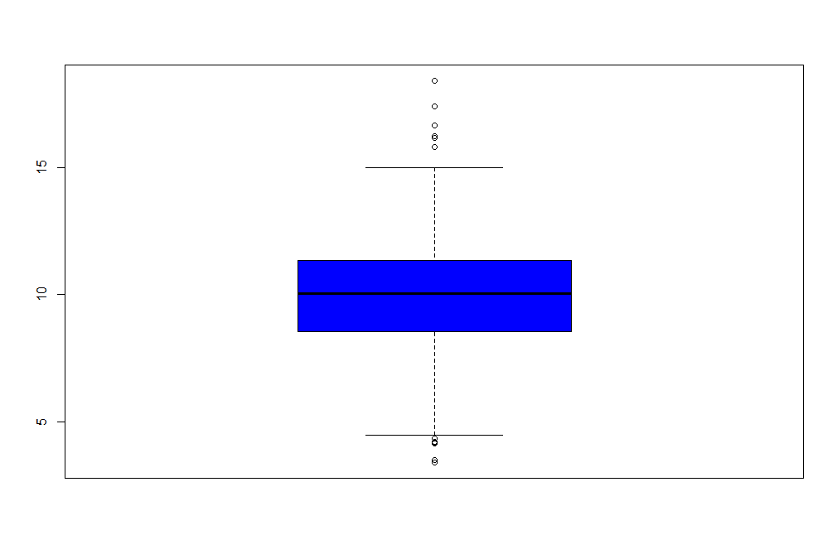

...

|====================== | 24%

| What do you think the horizontal line inside the box represents?

1: the mean

2: the median

3: the minimum value

4: the maximum value

Selection: 2

| You are doing so well!

|======================= | 25%

| The "whiskers" of the box (the vertical lines extending above and below the box) relate to the

| range parameter of boxplot, which we let default to the value 1.5 used by R. The height of the box

| is the interquartile range, the difference between the 75th and 25th quantiles. In this case that

| difference is 2.8. The whiskers are drawn to be a length of range*2.8 or 1.5*2.8. This shows us

| roughly how many, if any, data points are outliers, that is, beyond this range of values.

...

|========================= | 27%

| Note that boxplot is part of R's base plotting package. A nice feature that this package provides

| is its ability to overlay features. That is, you can add to (annotate) an existing plot.

...

|========================== | 28%

| To see this, run the R command abline with the argument h equal to 12. Recall that 12 is the EPA

| standard for air quality.

> abline(h = 12)

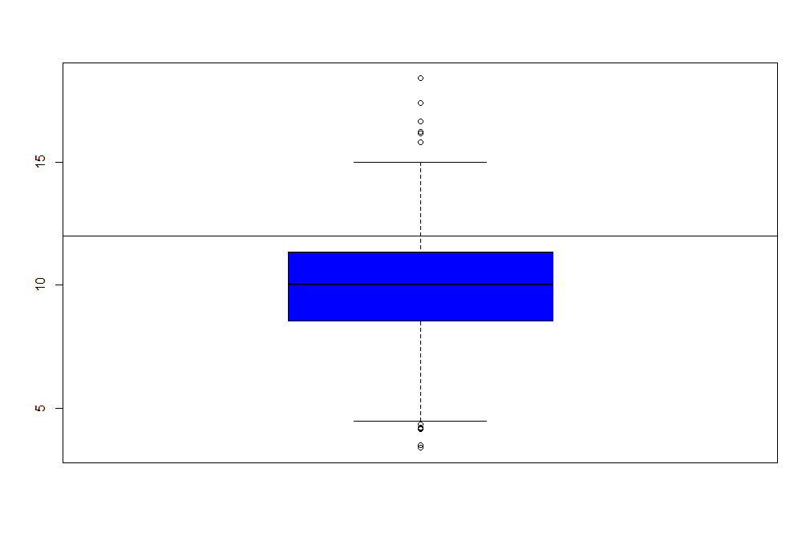

|  |
| --- |
| | You are doing so well!  |=========================== | 29%  | What do you think this command did?  1: drew a horizontal line at 12  2: drew a vertical line at 12  3: nothing  4: hid 12 random data points  Selection: 1  | Great job!  |============================ | 31%  | So abline "adds one or more straight lines through the current plot." We see from the plot that the  | bulk of the measured counties comply with the standard since they fall under the line marking that  | standard.  ...  |============================= | 32%  | Now use the R command hist (another function from the base package) with the argument ppm. Specify  | the color parameter col equal to "green". This will plot a histogram of the data.  > hist(ppm, col = "green")  | Excellent work!  |=============================== | 33%  | The histogram gives us a little more detailed information about our data, specifically the  | distribution of the pollution counts, or how many counties fall into each bucket of measurements. |
|  |
|  |

|================================ | 35%

| What are the most frequent pollution counts?

1: under 5

2: between 6 and 8

3: between 12 and 14

4: between 9 and 12

Selection: 4

| You are amazing!

|================================= | 36%

| Now run the R command rug with the argument ppm.

> rug(ppm)

| That's correct!

|================================== | 37%

| This one-dimensional plot, with its grayscale representation, gives you a little more detailed

| information about how many data points are in each bucket and where they lie within the bucket. It

| shows (through density of tick marks) that the greatest concentration of counties has between 9 and

| 12 micrograms per cubic meter just as the histogram did.

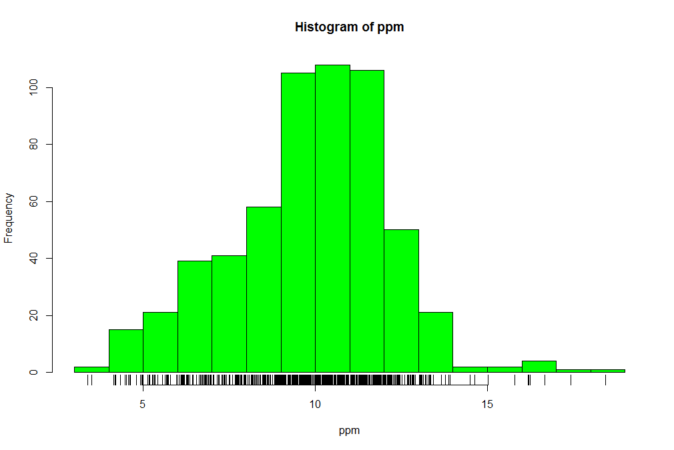

|==================================== | 39%

| To illustrate this a little more, we've defined for you two vectors, high and low, containing

| pollution data of high (greater than 15) and low (less than 5) values respectively. Look at low now

| and see how it relates to the output of rug.

> low

[1] 3.494351 4.186090 4.917140 4.504539 4.793644 4.601408 4.195688 4.625279 4.460193 4.978397

[11] 4.324736 4.175901 3.382626 4.132739 4.955570 4.565808

| You are doing so well!

|===================================== | 40%

| It confirms that there are two data points between 3 and 4 and many between 4 and 5. Now look at

| high.

> high

[1] 16.19452 15.80378 18.44073 16.66180 15.01573 17.42905 16.25190 16.18358

| You nailed it! Good job!

|====================================== | 41%

| Again, we see one data point greater than 18, one between 17 and 18, several between 16 and 17 and

| two between 15 and 16, verifying what rug indicated.

...

|======================================= | 43%

| Now rerun hist with 3 arguments, ppm as its first, col equal to "green", and the argument breaks

| equal to 100.

> hist(ppm, col = "green", breaks = 100)

| You got it right!

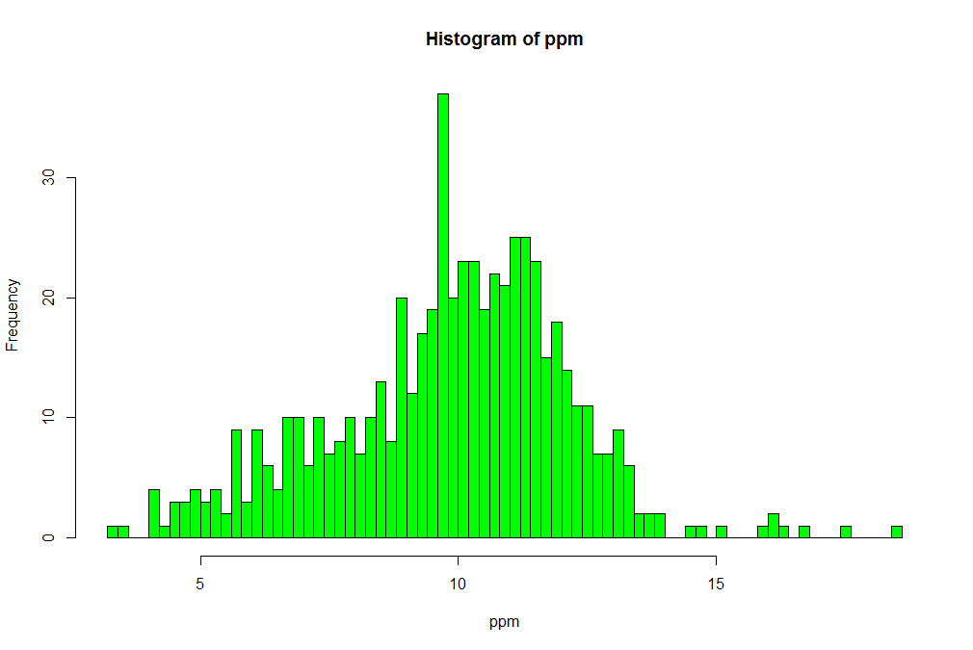

|======================================== | 44%

| What do you think the breaks argument specifies in this case?

1: the number of buckets to split the data into

2: the number of data points to graph

3: the number of counties exceeding the EPA standard

4: the number of stars in the sky

Selection: 1

| Keep working like that and you'll get there!

|========================================== | 45%

| So this histogram with more buckets is not nearly as smooth as the preceding one. In fact, it's a

| little too noisy to see the distribution clearly. When you're plotting histograms you might have to

| experiment with the argument breaks to get a good idea of your data's distribution. For fun now,

| rerun the R command rug with the argument ppm.

> rug(ppm)

| All that practice is paying off!

|=========================================== | 47%

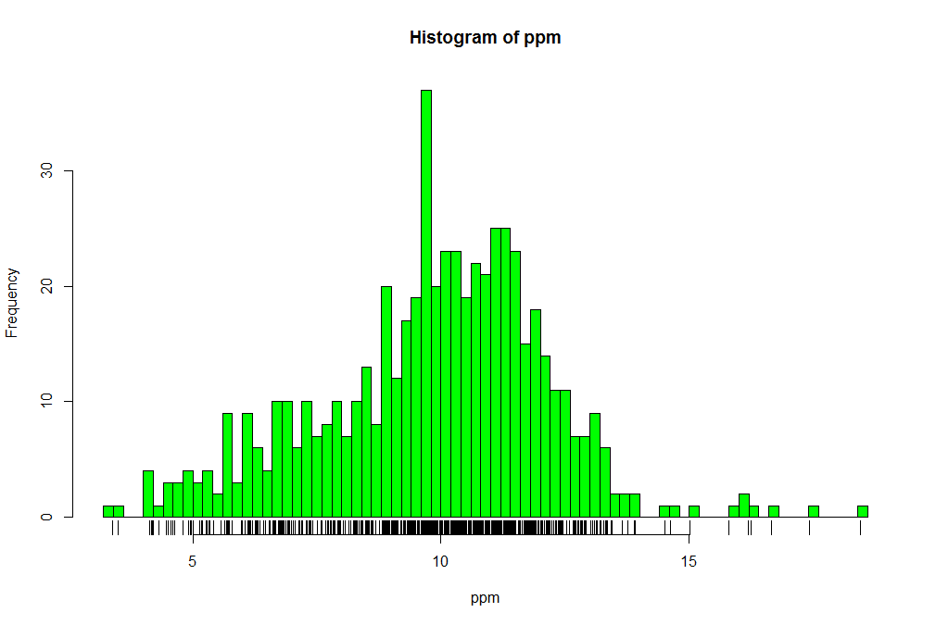

| See how rug works with the existing plot? It automatically adjusted its pocket size to that of the

| last plot plotted.

...

|============================================ | 48%

| Now rerun hist with ppm as the data and col equal to "green".

> hist(ppm, col = "green")

| You are quite good my friend!

|============================================= | 49%

| Now run the command abline with the argument v equal to 12 and the argument lwd equal to 2.

> abline(v = 12, lwd = 2)

| That's correct!

|=============================================== | 51%

| See the vertical line at 12? Not very visible, is it, even though you specified a line width of 2?

| Run abline with the argument v equal to median(ppm), the argument col equal to "magenta", and the

| argument lwd equal to 4.

> abline(v = median(ppm), col = "magenta", lwd = 4)

| Your dedication is inspiring!

|================================================ | 52%

| Better, right? Thicker and more of a contrast in color. This shows that although the median (50%)

| is below the standard, there are a fair number of counties in the U.S that have pollution levels

| higher than the standard.

...

|================================================= | 53%

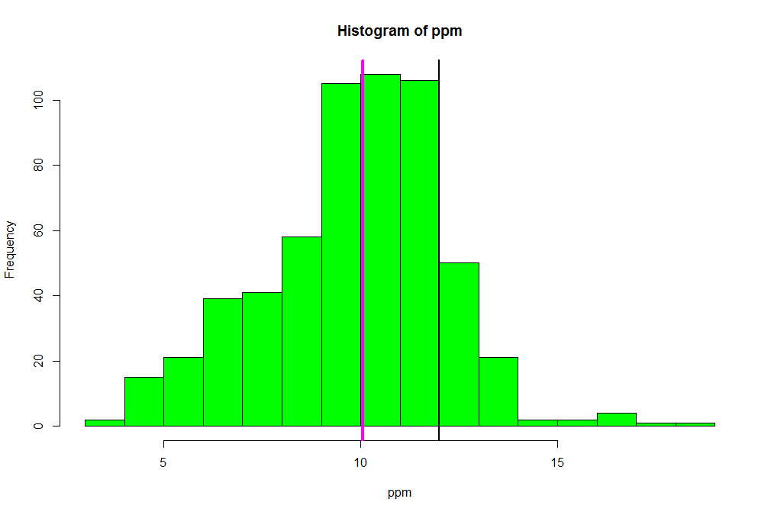

| Now recall that our pollution data had 5 columns of information. So far we've only looked at the

| pm25 column. We can also look at other information. To remind yourself what's there run the R

| command names with pollution as the argument.

> names(pollution)

[1] "pm25" "fips" "region" "longitude" "latitude"

| You got it!

|================================================== | 55%

| Longitude and latitude don't sound interesting, and each fips is unique since it identifies states

| (first 2 digits) and counties (last 3 digits). Let's look at the region column to see what's there.

| Run the R command table on this column. Use the construct pollution$region. Store the result in the

| variable reg.

> reg <- table(pollution$region)

| That's the answer I was looking for.

|==================================================== | 56%

| Look at reg now.

> reg

east west

442 134

| That's a job well done!

|===================================================== | 57%

| Lot more counties in the east than west. We'll use the R command barplot (another type of

| one-dimensional summary) to plot this information. Call barplot with reg as its first argument, the

| argument col equal to "wheat", and the argument main equal to the string "Number of Counties in

| Each Region".

> barplot(reg, col = "wheat", main = "Number of Counties in Each Region")

| That's the answer I was looking for.

|====================================================== | 59%

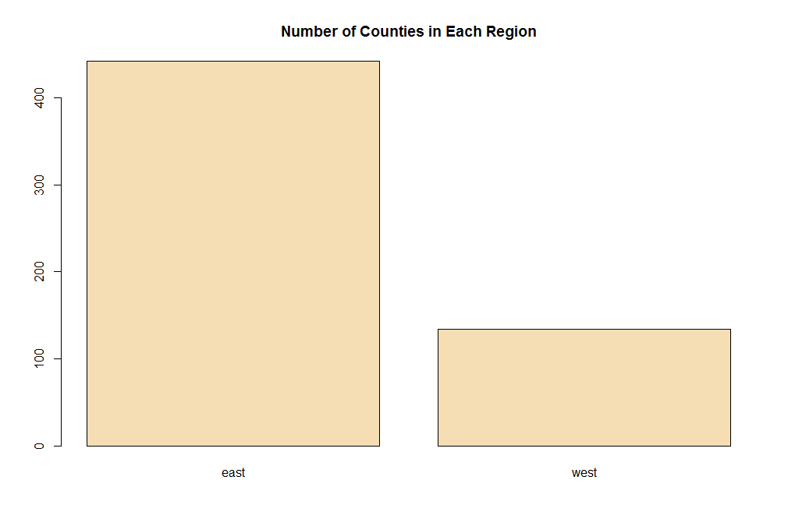

| What do you think the argument main specifies?

1: the x axis label

2: the title of the graph

3: the y axis label

4: I can't tell

Selection: 2

| Keep working like that and you'll get there!

|======================================================= | 60%

| So we've seen several examples of one-dimensional graphs that summarize data. Two dimensional

| graphs include scatterplots, multiple graphs which we'll see more examples of, and overlayed

| one-dimensional plots which the R packages such as lattice and ggplot2 provide.

...

|======================================================== | 61%

| Some graphs have more than two-dimensions. These include overlayed or multiple two-dimensional

| plots and spinning plots. Some three-dimensional plots are tricky to understand so have limited

| applications. We'll see some examples now of more complicated graphs, in particular, we'll show two

| graphs together.

...

|========================================================== | 63%

| First we'll show how R, in one line and using base plotting, can display multiple boxplots. We

| simply specify that we want to see the pollution data as a function of region. We know that our

| pollution data characterized each of the 576 entries as belonging to one of two regions (east and

| west).

...

|=========================================================== | 64%

| We use the R formula y ~ x to show that y (in this case pm25) depends on x (region). Since both

| come from the same data frame (pollution) we can specify a data argument set equal to pollution. By

| doing this, we don't have to type pollution$pm25 (or ppm) and pollution$region. We can just specify

| the formula pm25~region. Call boxplot now with this formula as its argument, data equal to

| pollution, and col equal to "red".

> boxplot(pm25~region, data = pollution, col = "red")

| You are quite good my friend!

|============================================================ | 65%

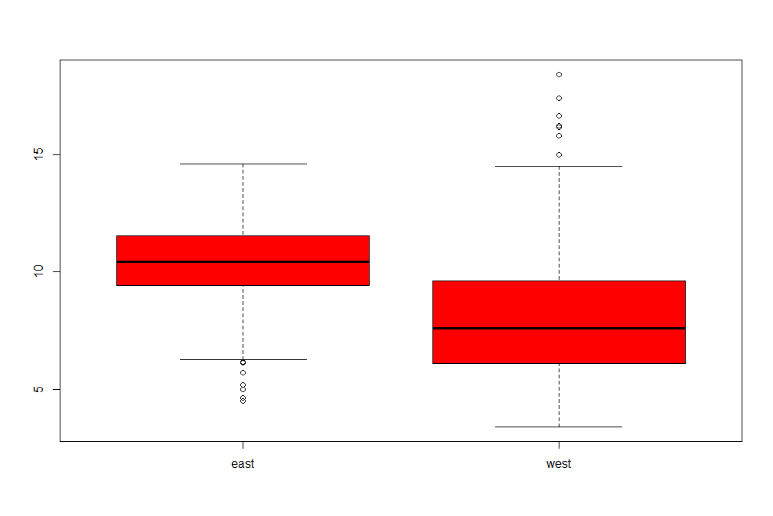

| Two for the price of one! Similarly we can plot multiple histograms in one plot, though to do this

| we have to use more than one R command. First we have to set up the plot window with the R command

| par which specifies how we want to lay out the plots, say one above the other. We also use par to

| specify margins, a 4-long vector which indicates the number of lines for the bottom, left, top and

| right. Type the R command par(mfrow=c(2,1),mar=c(4,4,2,1)) now. Don't expect to see any new result.

> par(mfrow=c(2,1), mar=c(4,4,2,1))

| You got it right!

|============================================================= | 67%

| So we set up the plot window for two rows and one column with the mfrow argument. The mar argument

| set up the margins. Before we plot the histograms let's explore the R command subset which, not

| surprisingly, "returns subsets of vectors, matrices or data frames which meet conditions". We'll

| use subset to pull off the data we want to plot. Call subset now with pollution as its first

| argument and a boolean expression testing region for equality with the string "east". Put the

| result in the variable east.

> east <- subset(pollution, region = "east")

| You almost had it, but not quite. Try again. Or, type info() for more options.

| Type east <- subset(pollution,region=="east") at the command prompt.

> east <- subset(pollution, region == "east")

| That's a job well done!

|=============================================================== | 68%

| Use head to look at the first few entries of east.

> head(east)

pm25 fips region longitude latitude

1 9.771185 01003 east -87.74826 30.59278

2 9.993817 01027 east -85.84286 33.26581

3 10.688618 01033 east -87.72596 34.73148

4 11.337424 01049 east -85.79892 34.45913

5 12.119764 01055 east -86.03212 34.01860

6 10.827805 01069 east -85.35039 31.18973

| Keep up the great work!

|================================================================ | 69%

| So east holds more information than we need. We just want to plot a histogram with the pm25

| portion. Call hist now with the pm25 portion of east as its first argument and col equal to "green"

| as its second.

> hist(east$pm25, col = "green")

| Excellent work!

|================================================================= | 71%

| See? The command par told R we were going to have one column with 2 rows, so it placed this

| histogram in the top position.

...

|================================================================== | 72%

| Now, here's a challenge for you. Plot the histogram of the counties from the west using just one R

| command. Let the appropriate subset command (with the pm25 portion specified) be the first argument

| and col (equal to "green") the second. To cut down on your typing, use the up arrow key to get

| your last command and replace "east" with the subset command. Make sure the boolean argument checks

| for equality between region and "west".

> hist(subset(pollution, region == "west")$pm25, col = "green")

| Keep working like that and you'll get there!

|=================================================================== | 73%

| See how R does all the labeling for you? Notice that the titles are different since we used

| different commands for the two plots. Let's look at some scatter plots now.

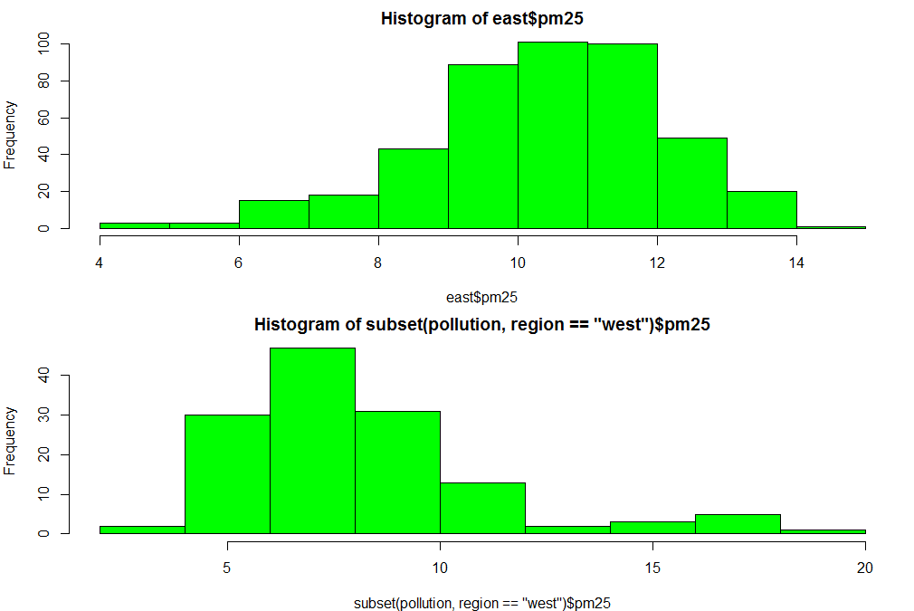

|===================================================================== | 75%

| Scatter plots are two-dimensional plots which show the relationship between two variables, usually

| x and y. Let's look at a scatterplot showing the relationship between latitude and the pm25 data.

| We'll use plot, a function from R's base plotting package.

...

|====================================================================== | 76%

| We've seen that we can use a function call as an argument when calling another function. We'll do

| this again when we call plot with the arguments latitude and pm25 which are both from our data

| frame pollution. We'll call plot from inside the R command with which evaluates "an R expression in

| an environment constructed from data". We'll use pollution as the first argument to with and the

| call to plot as the second. This allows us to avoid typing "pollution$" before the arguents to

| plot, so it saves us some typing and adds to your base of R knowledge. Try this now.

> with(pollution, plot(latitude, pm25))

| Your dedication is inspiring!

|======================================================================= | 77%

| Note that the first argument is plotted along the x-axis and the second along the y. Now use abline

| to add a horizontal line at 12. Use two additional arguments, lwd equal to 2 and lty also equal to

| 2. See what happens.

> abline(h = 12, lwd = 2, lty = 2)

| You are really on a roll!

|======================================================================== | 79%

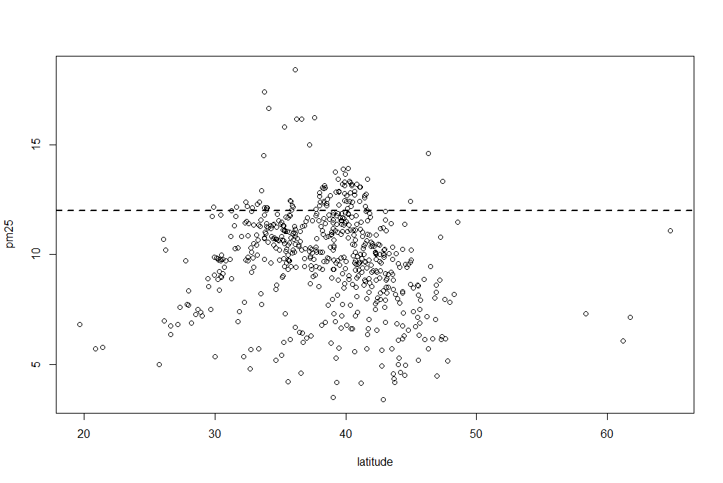

| See how lty=2 made the line dashed? Now let's replot the scatterplot. This time, instead of using

| with, call plot directly with 3 arguments. The first 2 are pollution$latitude and ppm. The third

| argument, col, we'll use to add color and more information to our plot. Set this argument (col)

| equal to pollution$region and see what happens.

> plot(pollution$latitude, ppm, col = pollution$region)

| You are really on a roll!

|========================================================================== | 80%

| We've got two colors on the map to distiguish between counties in the east and those in the west.

| Can we figure out which color is east and which west? See that the high (greater than 50) and low

| (less than 25) latitudes are both red. Latitudes indicate distance from the equator, so which half

| of the U.S. (east or west) has counties at the extreme north and south?

1: east

2: west

Selection: 2

| You are really on a roll!

|=========================================================================== | 81%

| As before, use abline to add a horizontal line at 12. Use two additional arguments, lwd equal to 2

| and lty also equal to 2.

> abline(h = 12, lwd = 2, lty = 2)

| Nice work!

|============================================================================ | 83%

| We see many counties are above the healthy standard set by the EPA, but it's hard to tell overall,

| which region, east or west, is worse.

...

|============================================================================= | 84%

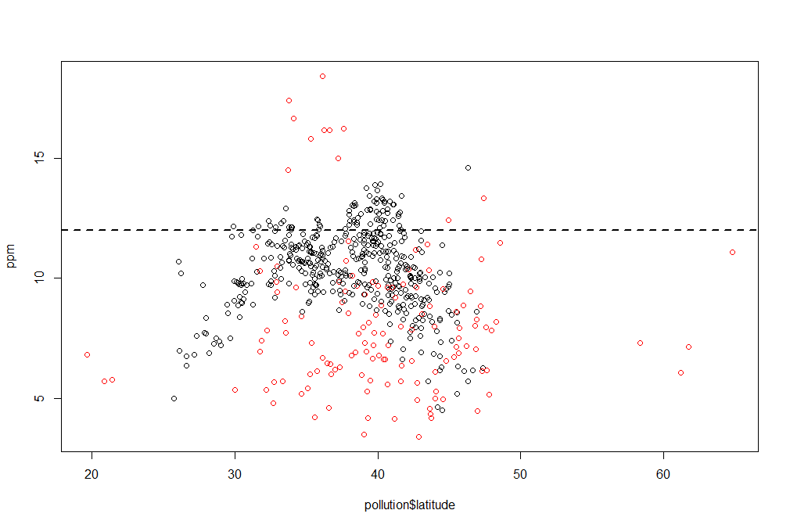

| Let's plot two scatterplots distinguished by region.

...

|=============================================================================== | 85%

| As we did with multiple histograms, we first have to set up the plot window with the R command par.

| This time, let's plot the scatterplots side by side (one row and two columns). We also need to use

| different margins. Type the R command par(mfrow = c(1, 2), mar = c(5, 4, 2, 1)) now. Don't expect

| to see any new result.

> par(mfrow = c(1, 2), mar = c(5, 4, 2, 1))

| That's the answer I was looking for.

|================================================================================ | 87%

| For the first scatterplot, on the left, we'll plot the latitudes and pm25 counts from the west. We

| already pulled out the information for the counties in the east. Let's now get the information for

| the counties from the west. Create the variable west by using the subset command with pollution as

| the first argument and the appropriate boolean as the second.

> west <- subset(pollution, region == "west")

| You're the best!

|================================================================================= | 88%

| Now call plot with three arguments. These are west$latitude (x-axis), west$pm25 (y-axis), and the

| argument main equal to the string "West" (title). Do this now.

> plot(west$latitude, west$pm25, main = "West")

| You got it!

|================================================================================== | 89%

| For the second scatterplot, on the right, we'll plot the latitudes and pm25 counts from the east.

...

|=================================================================================== | 91%

| As before, use the up arrow key and change the 3 "west" strings to "east".

> plot(east$latitude, east$pm25, main = "East")

| Keep working like that and you'll get there!

|===================================================================================== | 92%

| See how R took care of all the details for you? Nice, right? It looks like there are more dirty

| counties in the east but the extreme dirt (greater than 15) is in the west.

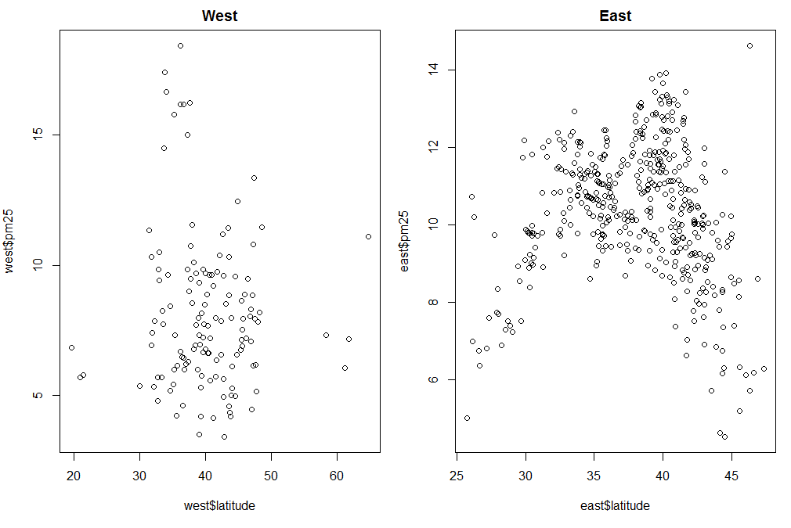

...

|====================================================================================== | 93%

| Let's summarize and review.

...

|======================================================================================= | 95%

| Which of the following characterizes exploratory plots?

1: quick and dirty

2: quick and dead

3: slow and steady

4: slow and clean

Selection: 1

| Your dedication is inspiring!

|======================================================================================== | 96%

| True or false? Plots let you summarize the data (usually graphically) and highlight any broad

| features

1: True

2: False

Selection: 1

| Keep working like that and you'll get there!

|========================================================================================== | 97%

| Which of the following do plots NOT do?

1: Conclude that you are ALWAYS right

2: Summarize the data (usually graphically) and highlight any broad features

3: Explore basic questions and hypotheses (and perhaps rule them out)

4: Suggest modeling strategies for the "next step"

Selection: 1

| You got it!

|=========================================================================================== | 99%

| Congrats! You've concluded exploring this lesson on graphics. We hope you didn't find it too quick

| or dirty.

...

|============================================================================================| 100%